**Variant 1: With power supply**

It is intended to take the reading of a flowmeter that provides 4-20mA output using low cost devices. For this, it is necessary to convert the signal to voltage values ​​that the microcontroller is capable of processing, which requires the use of a current-to-voltage converter. The data is processed by the ESP32 that allows the sending of information both by Wi-Fi and by Bluetooth, a GSM module is included to send the data using mobile telephony to the central PLC.

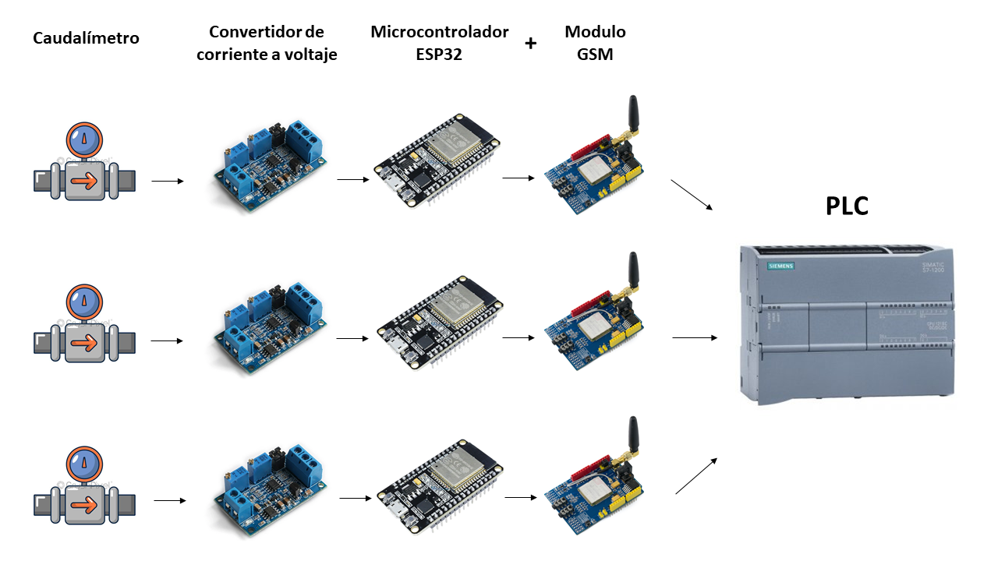

Figure 1 Proposed architecture

**Variant 2: With Battery and solar panel**

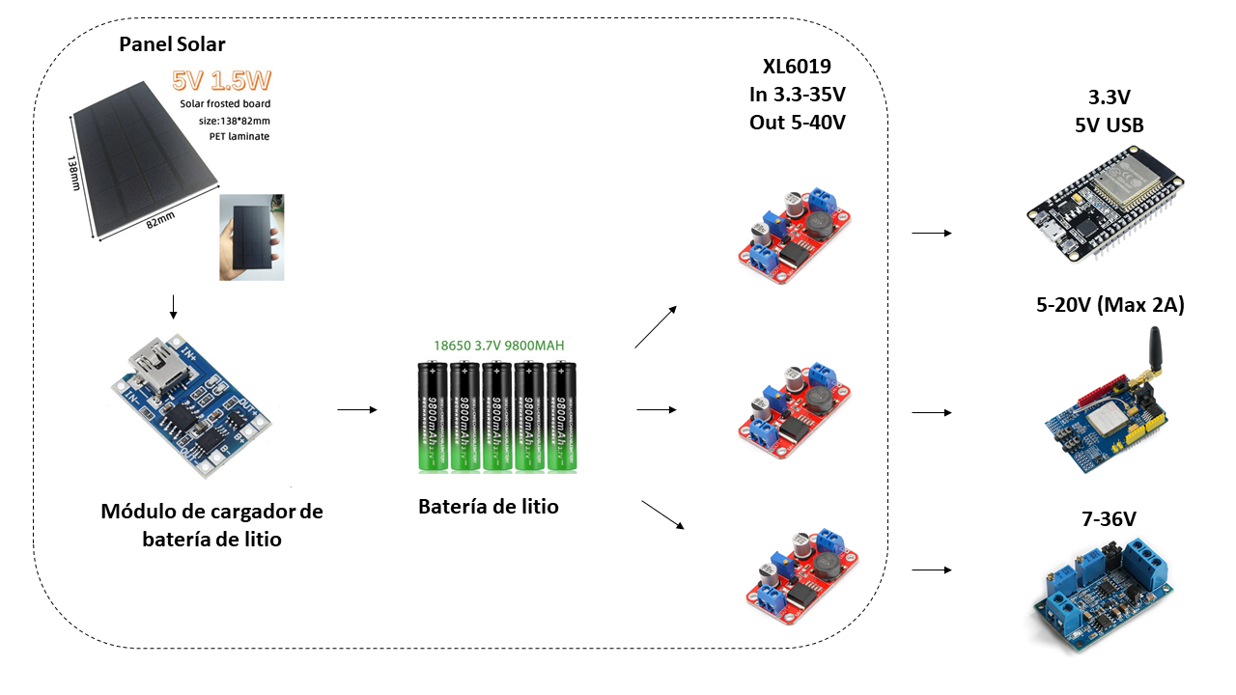

Figure 2 Proposed architecture for power supply by solar panel and battery

If you want the system to work autonomously, it is possible to place rechargeable batteries and solar panels that provide it with power. In addition to the components described in variant 1, the modules that are framed in Figure 2 should be incorporated and the power supply can be dispensed with.